Rosslyn Hill Unitarian Chapel
Annual General Meeting
On Zoom at 4pm Sunday March 20th 2022

(Please log in at 15.50 to avoid delays in the waiting room and enable a prompt start).
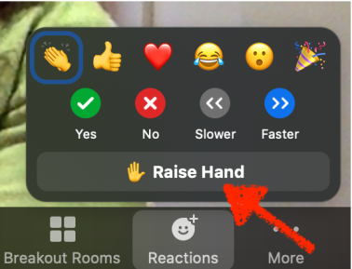
For any voting, we will use the ‘raise hand’ function/icon which can be accessed under 'Reactions' or 'Participants' depending on your version of Zoom.
See Zoom doc for more instructions.

Agenda
16:00 1.Devotional
16:05 2. Welcome and introduction to the meeting (Chair)
16:10 3. Establish a Quorum (Secretary)
16:15 4. Approval of minutes of March 2021 AGM
16:20 5. Chair’s report
16:35 6. Presentation & Questions on the committee reports
16:50 8. Presentation of Financial accounts for approval
17:00 9. Election of Board members (Trustees)
17:05 10. Election of Elders
17:10 11. Endorsement of GA delegates/ LDPA rep confirmation.
17:15 12 Roof Renovations Report by Ryan Bunce, Lead Consultant
BSc(Hons) DipProjMan PGDipCHE MRICS FRSA
13 Vote on Roof Renovations Proposal
17:25 12. Any other business
17:30 13. Close of Meeting
Right to Light issue needs to be actioned in 2025

